Exercise 1: Configuring a Basic Spring Application
Scenario:
Your company is developing a web application for managing a library. You need to use the Spring Framework to handle the backend operations.
Steps:
- Set Up a Spring Project:
  - Create a Maven project named LibraryManagement.
  - Add Spring Core dependencies in the pom.xml file.
- Configure the Application Context:
  - Create an XML configuration file named applicationContext.xml in the src/main/resources directory.
  - Define beans for BookService and BookRepository in the XML file.
- Define Service and Repository Classes:
  - Create a package com.library.service and add a class BookService.
  - Create a package com.library.repository and add a class BookRepository.
- Run the Application:
  - Create a main class to load the Spring context and test the configuration.
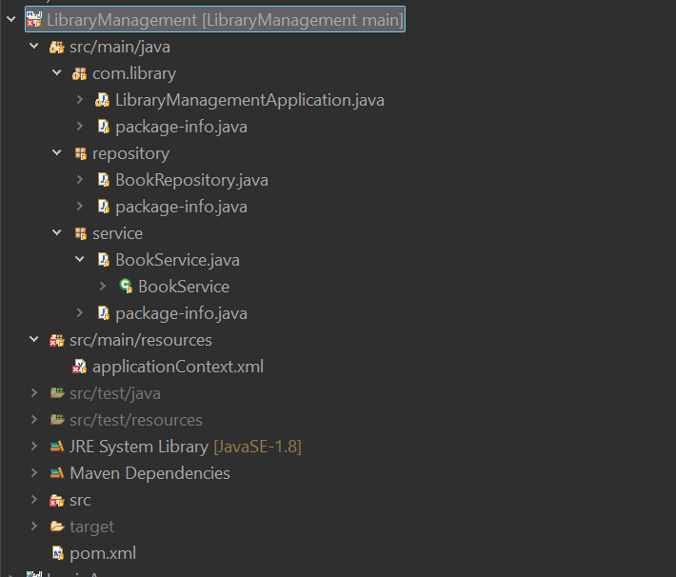

<?xml version="1.0" encoding="UTF-8"?>

<beans xmlns="http://www.springframework.org/schema/beans"
xmlns:xsi="http://www.w3.org/2001/XMLSchema-instance"
xsi:schemaLocation="
http://www.springframework.org/schema/beans
https://www.springframework.org/schema/beans/spring-beans.xsd">

<bean id="bookRepository"
class="repository.BookRepository"/>

<bean id="bookService"
class="service.BookService">

<property name="repository"
ref="bookRepository"/>

</bean>

</beans>

package repository;

public class BookRepository {

public void showBooks() {
System.out.println("Fetching books from the database");
}

}

Exercise 2: Implementing Dependency Injection
Scenario:
In the library management application, you need to manage the dependencies between the BookService and BookRepository classes using Spring's IoC and DI.
Steps:
- Modify the XML Configuration:
  - Update applicationContext.xml to wire BookRepository into BookService.
- Update the BookService Class:
  - Ensure that BookService class has a setter method for BookRepository.
- Test the Configuration:
  - Run the LibraryManagementApplication main class to verify the dependency injection.
Dependency injection:
package service;
import repository.BookRepository;

public class BookService {
private BookRepository br;
public void setRepository(BookRepository br) {
this.br = br;
}
public void displayBooks() {
br.showBooks();
}

}

Output:
